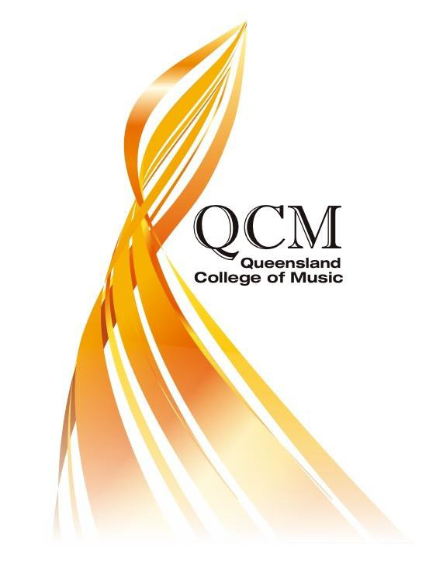
ENROLMENT KIT
Level 1, Unit 5, 14 Annerley Road Woolloongabba QLD 4102
www.qcm.qld.edu.au admin@qcm.qld.edu.au 07 3191 8532
ABN: 57 164 451 012 RTO: 40821 CRICOS: 03466G

WELCOME ENROLMENT KIT
- Qualifications

- Delivery models

- Rights and responsibilities

- Consent forms
  - Authority to release to a third party
  - Permission to store USI
  - Permission to photograph
  - Medical information

- Verification

- An enrolment form

- A complaints and appeals form

- Fee schedule

QUALIFICATIONS
The amount of training varies with the qualification however all qualifications require individual practice time, rehearsals, performances, and individual study time.

Qualification | Terms | Weeks per term | Hours per week | Additional hours
CUA20615 Certificate II in Music Industry | 4 | 8 | 4 | Individual practice time, rehearsals, performances, and individual study time.
CUA30915 Certificate III in Music Industry | 4 | 8 | 6
CUA40915 Certificate IV in Music Industry | 4 | 8 | 20
CU50815 Diploma of Music Industry | 4 | 8 | 20

The level of qualification and the units of competency will be discussed with you at the time of the audition. Audition details can be found on the website www.qcm.qld.edu.au

DELIVERY MODELS

Students study with QCM in different ways. Some students attend the College, some high school students study in their school using QCM resources and some students are distance music education students.

- A student can attend the College for 20 hours a week for four, 8 week terms.

- A senior high school student studying music at school can attend the College for one day a week for four, 8 week terms.

- A senior high school student can be in a school music class where the school has an agreement with QCM to deliver training on its behalf. QCM provides all learning materials and assessment items to the supervising teacher. All work is assessed to determine competency by QCM staff.

- A senior high school student can apply to study with QCM as a distance music education student. The school will approve such arrangement and provide educational support to the learner as detailed in an agreement with the school. QCM provides all learning materials and assessment items to the student. All work is assessed to determine competency by QCM staff. Students will be required to forward videos of performances and evidence of instrumental instruction, practice and rehearsal.

RIGHTS AND RESPONSIBILITIES

RIGHTS AND RESPONSIBILITIES OF LEARNERS
RIGHTS | RESPONSIBILITIES
- access to a safe learning | - attend all classes, undertake personal and group practices as scheduled and report absences to the College  - dress in a manner that reflects well on the College with attention to personal appearance and hygiene  - participate in public performances as requested  - complete all assessment tasks as required and within timelines stated  - abide by the policies and procedures of the Queensland College of Music. The College has procedures in relation to reporting hazards, incidents and injuries, dealing with emergencies and accessing First Aid facilities.  - take the initiative to consult and negotiate with trainers when problems arise  - behave in an acceptable manner, use appropriate language and respect all learners  - ensure a safe learning environment for everyone. No alcohol, drugs or smoking on the property  - respect for College property and the property of others. No eating or drinking when working at computers or with instruments  - inform QCM of change to contact details  - pay fees in a timely manner  - conserve resources
environment
- access to personal records and
results
- personal information to remain
private and confidential
- quality training, resources and
equipment
- to provide feedback on training
and assessment
- assessment that is fair and flexible
and that offers RPL opportunities
and adjustment of assessment
tasks
- to constructive feedback on
assessment tasks and an
opportunity to resubmit
- educational and support services
including literacy and numeracy
support
- access to complaints and appeals
processes

CONSENT FORMS
Authority to release information to a third party

Completing and signing this form will allow a representative from the Queensland College of Music Pty Ltd to discuss and release aspects of your training records held by QCM to government and regulatory authorities.

Name: ……………………………………………………………………………………………………………………………………………. Contact address: …………………………………………………………………………………………………………………………….
………………………………………………………………………………………………………………………………………………………. Contact Phone: ……………………………………………………………………………………………………………………………. Email Address: ………………………………………………………………………………………………………………………………..

……………………………..hereby authorises QCM to the release of information to government and regulatory authorities as required relating to a person’s enrolment and completion documentation with the Queensland College of Music Pty Ltd.

Student Name: …………………………………………………………………………………………………………………………… Signature: …………………………………………………………………………………………Date: ……………………………
Write “Signed by Me (name)”

Parent/Guardian Name:
………………………………………………………………………………………………………………………..……………………...

Signature: …………………………………………………………………………………………Date: ……………………………
Write “Signed by Me (name)”

PERMISSION TO STORE USI FOR STUDENTS

The Australian Government requires all students participating in vocational education qualifications to have a Unique Student Identifier (USI). The Queensland College of Music is required to collect and verify a student’s USI for the purpose of reporting on training activities and to issue a qualification.

  - I give permission for the Queensland College of Music as a registered training organisation to store my USI in the College’s database.

……………………………………………. ………………………………………….

Name of Parent or Guardian Name of Student

…………………………………………….. ………………………………………………

Signature of Parent or Guardian Signature of Student

Write “Signed by Me (name)” Write “Signed by Me (name)”

………………………………………………………. ………………………………………………

Date Date

Photographic / Media Consent Form

I hereby consent to the collection and use of my personal images by photography or video recording.
I acknowledge these may be used on the Queensland College of Music Pty Ltd website, in newsletters and publications.
I further acknowledge that my image may be used by the College to promote the College in the future.
I understand that no personal information, such as names, will be used in any publications unless express consent is given.
I also understand that my consent can be withdrawn at anytime in writing to the Director at Queensland College of Music Pty Ltd.

CONSENT FORM

I ……………………………………………………………………………………………………
Name of person giving consent & parent/ guardian if under 18 years of age

Consent to the use of photographs or video footage for use on the Queensland College of Music Pty Ltd website, in newsletters and publications.
Consent to the use of photographs or video footage being used to promote future QCM events.
I further understand that this consent may be withdrawn by me at anytime, upon written notice.
I give this consent voluntarily.

………………………………………………….. ……………………………………………….. Signature of person giving consent Signature of parent/ guardian < 18
Write “Signed by Me (name)” Write “Signed by Me (name)”

Date:

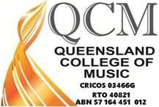
MEDICAL FORM

Student and contact details
Student name:
School:
Emergency contact:
Please note - parents are automatically the 1st and 2nd emergency contact unless otherwise stated
Relationship to the student:
Tel (home):
Tel (work):
Tel (mobile):
24/7 contact number required
Email:

Student’s doctor details
Name of doctor: |  | Tel:
Name of medical practice:
Address:
Email:

Medical specialist details (if applicable)
Name of doctor: |  | Tel:
Address:
Email:

It is important to answer the following four questions and provide as much information as possible.
- Does the student have a pre-existing medical condition (please circle): Yes No If yes, please provide details (e.g. severity, medication, special care required):

For severe medical conditions, please attach an Emergency Action Plan

- Has the student been diagnosed with any medical condition, not listed above, that a medical practitioner should be aware of if medical treatment is required (including allergies to medication)? (please circle) Yes No

If yes, please provide details (e.g. severity, medication, special care required):

- Please list any conditions or health issues, not listed above, that the College should be aware of while they are responsible for the health, safety and welfare of the student.

Medication

Prescribed medication: | •  •  •
Please give details of any prescribed medication being taken by your child – include dosage, frequency and any doctor’s instructions:

Non-prescribed medication: | •  •  •

Please give details of any non-prescribed medication being taken by your child (For example: paracetamol, travel sickness tablets, diarrhoea tablets, hay fever/allergy tablets, throat lozenges, vitamins):

Administration of medication

All medications must be labelled with the student’s name and kept with the student at all times during their time at the College and clear written instructions with respect to prescribed medication (and non-prescribed medication, if necessary) must be handed to the supervising staff including dosage to be taken, specific storage conditions, time to be taken and details of administration (for example, to be taken with food). It will be the responsibility of the student to keep his/her own medications, to store securely and appropriately and administer as required. All medication must be supplied in original packaging. In the case of prescribed medication, the medication must be supplied with a doctor’s note confirming the prescription and necessity for a particular condition.
QCM is responsible for the health, safety and welfare of students while they are attending the College and while they are in our care. If the Student becomes ill or has an accident, the supervising staff will contact the Student’s emergency contact immediately, in advance of treatment being sought. However, this will not necessarily happen:
  - for minor illness or injury;
  - in the event of an emergency where immediate action is required;
  - if the parent or emergency contact cannot be reached;
  - if it is impractical to contact the emergency contact before treatment is sought.

I hereby authorise any of the supervising staff to:

- obtain, on my child’s behalf, such medical assistance my child may require in the event of an accident or illness; and
- consent to my child receiving any medical or surgical attention deemed necessary by a medical practitioner; and
- administer such first-aid as the supervising staff considers to be reasonably necessary; and
- administer or assist my child administer their medication referred to above, in the event of an emergency situation.

I accept liability for all costs incurred in obtaining such medical treatment and undertake to reimburse the College the full amount of any costs incurred on my child’s behalf.

Declaration

- I hereby declare that the foregoing medical information is true and correct and includes all relevant information.
Student Name (Printed) Signature
Date
Parent Name (Printed)
Signature
Date
Parent Name (Printed)
Signature
Date

VERIFICATIONS

ALL STUDENTS

I confirm that I have read and accept the terms and conditions related to this enrolment as outlined in the Learner Handbook.
- I am aware of the qualification and units of competency I am studying
- I understand attendance requirements and my delivery mode
- I am aware of assessment expectations
- I have been informed of my trainers, assessors and contact people
- I am aware of fees to be paid and refund policy
Participant Signature: Date: Parent/Guardian Signature: Date:
(for students under the age of 18)

PARTNER SCHOOLS
XXXXXXXXXXXXXXXX is providing training on behalf of QCM Pty Ltd using resources and assessments belonging to QCM. All assessment decisions will be made by QCM and qualifications issued by QCM. A representative of QCM will visit the school each term.

DISTANCE MUSIC EDUCATION STUDENTS

XXXXXXXXXXXXXX will provide educational support to you while studying in distance mode with QCM Pty Ltd. All learning materials and assessments will be forwarded to you and submitted to the College for assessment decisions. QCM will issue your qualification

You will be provided with a support person in your school and a contact person at the Queensland College of Music. A representative of QCM will visit you once a term. This visit can take place at your school if this is appropriate for all parties.

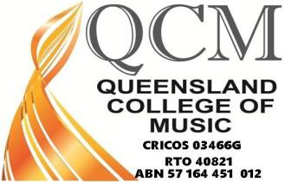

Queensland College of Music Pty Ltd Enrolment Form
Please complete all details on this enrolment form. This will be used to enrol you in the course you are seeking and provide statistical data as required by our registration as a training organisation.

Qualification Name:

Status: RPL/Full-time/Part-time

Delivery Method: At QCM/At School/ Distance music education student

Participated in audition: □ Yes □ No

USI number: LUI number:

Personal details

Title: First Name: Middle Name: Last Name:

Date of Birth: / /
2016 School Year (if applicable): □10 □11 □12

Gender Details: □ Male □ Female

Residential Address:

Street:

Suburb: Postcode: State:

Postal Address: □ As above OR Fill out details below

Street:

Suburb: Postcode: State:

Contact Details:

Telephone: Mobile:

Email: Parents email:

School Contact Details (if applicable):

School Name: School Contact Name:

Contact Telephone: Contact Email:

Employment Data:

Of the following categories, which BEST describes your current employment status?

- Full-time employee □ Part-time employee □ Not employed (not seeking work)

- Self- employed □ Employer □ Employed – unpaid worker
- Unemployed (seeking F/T work) □ Unemployed (seeking P/T work) □ Student

Language and cultural diversity:

In which country were you born? City of Birth:

Do you have Australian citizenship? □ Yes □ No If No, Country of Citizenship

Do you speak a language other than English at home?

- No □ Yes please specify:

How well do you speak English?

- Very well □ Well □ Not well □ Not at all
Do you identify as being of Aboriginal or Torres Strait Islander origin?

- No □ Yes, Aboriginal □ Yes, Torres Strait Islander

Schooling:

Are you still attending secondary school? □ Yes □ No
Indicate the highest COMPLETED level of schooling and the year of completion.

- Year 12 or equivalent Year:
- Year 10 or equivalent Year:
- Year 8 or equivalent Year:
- Year 11 or equivalent Year:
- Year 9 or equivalent Year:

Previous Qualifications Achieved:

Have you successfully completed any of the following qualifications? □ Yes □ No

If yes, tick the applicable box or boxes.

- Bachelor degree or higher □ Diploma
- Certificate IV or Advanced Certificate
- Certificate III or trade certificate
- Certificate II

Disability:

Do you consider yourself to have a disability, impairment or a long term health condition?

- Yes □ No
If yes, please indicate the areas of disability, impairment or long-term health conditions.

- Hearing □ Physical
- Intellectual □ Mental
- Vision □ Learning
- Acquired Brain Impairment □ Medical Condition
- Other

If yes, please specify:

Reasons for Study

Of the following categories, which BEST describes your main reason for undertaking this qualification?

- to get a job □ to develop my existing business
- to start my own business □ to try for a different career
- to get a better job or promotion □ to get extra skills for my job
- it is a job requirement □ to get into another course of study
- for personal interest/ self-development □ Other

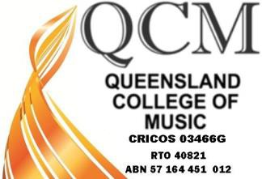

Queensland College of Music Pty Ltd

RTO 40821

Complaints and Appeals Form

Client’s Name:

Nature of Complaint or Appeal
Please use specific detail (dates etc)

Complaint or Grievance Against:

Client’s Signature: Date

Accepted by: Position:

Full Time Learners
Learners will be invoiced per term. The first term will include course fees for the term, any administration and resource charges. These charges are non-refundable. No refund is paid if a learner fails to attend for the term. Once enrolled in the term learners need to be committed and aim to complete at least three units of competency per term. If they withdraw, they can choose to enrol in another term within a twelve-month period or leave and receive a statement of attainment.

SCHEDULE OF FEES
AS AT 1st September, 2016 to 2017

Qualification | Course fees | Individual units
CUA20615  Certificate II in Music Industry  (8 units of competency) | $2200 | $275
CUA30915  Certificate III in Music Industry  (11 units of competency) | $3025 | $275
CUA40915  Certificate IV in Music Industry  (14 units of competency) | $3850 | $275
CUA50815  Diploma of Music Industry  (16 units of competency) | $7040 | $440

*For Partner Schools the cost per school student is $33 per unit of competency from Certificate II, III IV and Diploma and $100 Administration fee.
*For Distance Music Education Students the cost per student is $66 per unit of competency from Certificate II, III, IV and Diploma and $100 Administration fee.
* For high school students attending one day a week the cost is half the fees stated above.
Maximum Additional Charges
- Administration fee | $100
- Resource charge | $100
- Replacement certificate or statement | $20
- Audition fee | $60
- QCM T-Shirt  RPL Application  Certificate II, III and IV $660  Diploma $1320  Room Hire Per hour $20 | $25 | Per day | $200

Additional fees apply for additional studio times and additional individual lessons for instrumental and vocal studies, business and sound production units of competency.

Level 1, Unit 5, 14 Annerley Road Woolloongabba QLD 4102
www.qcm.qld.edu.au admin@qcm.qld.edu.au 07 3191 8532
ABN: 57 164 451 012 RTO: 40821 CRICOS: 03466G

