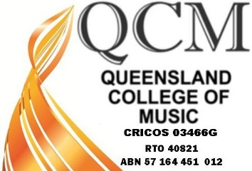

Queensland College of Music Pty Ltd
RTO 40821

Complaints and Grievances Form

Please complete this form to lodge a formal complaint.

We value your feedback and aim to resolve your complaint within 10 days.

Contact Details

Name:
Email: |  | Phone:
Details/cause of complaint/grievance
Complainant Signature:
Date:
Please complete this form and email to: admin@qcm.qld.edu.au

OFFICE USE
Date Received: |  | Complaint ID:
Accepted By: |  | Position:
Action Taken:
Resolution:
Complainant has been notified of receipt? |  |  |  | ❏ Yes | ❏ No
Complainant has been sent a written statement of actions taken? |  |  |  | ❏ Yes | ❏ No
Complaint has been added to the Complaints Register? |  |  |  | ❏ Yes | ❏ No
Complaint was referred to a third party for resolution? |  |  |  | ❏ Yes | ❏ No
Date complaint was resolved:
CEO Signature: |  |  | Date:

